Siesta Hills 2023 July Newsletter

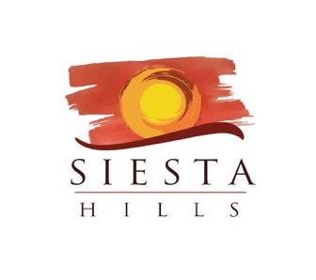

We would like to Thank everyone for attending the first Annual Member’s meeting on July 19th. It was a great turnout and very pleasing to see everyone getting the chance to meet each other and visit. Quite a bit of information was talked about and having Dustin with Total Lawn and Ryan and Dusty with APX hopefully helped answer some questions. Thank you again for being very patient with the timing of some of the projects in our community and hopefully patience will be a virtue when we can all enjoy the Clubhouse and all the amenities.

Enclosed are a few attachments that we discussed at the meeting:

- Members Directory…please make sure your contact information is correct.
- Log In/Auto Pay directions.
- Invite to a Social Gathering at Javen’s Winery on August 17th.
- Renderings of the revised Clubhouse.

As mentioned before in the Annual meeting we will be communicating on a regular basis about the progress on these projects and will be sending periodic updates from APX to keep everyone involved. Thanks again and enjoy the rest of the Summer.

Siesta Hills Team

